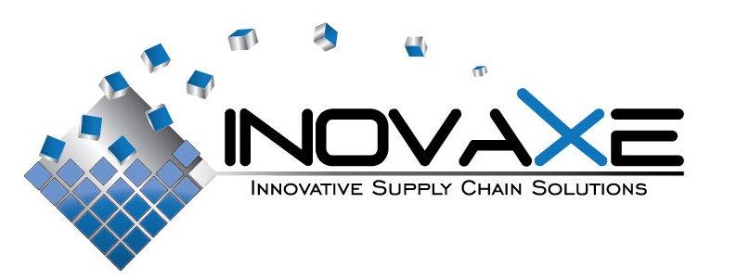

FOR IMMEDIATE RELEASE

Contact:
Inovaxe Corp.
Deerfield Beach, FL
9454.531.1363
E-mail: info@inovaxe.com
www.inovaxe.com

Don’t Miss Inovaxe’s Latest Handling and Inventory Control Solutions at SMTAI 2010

DEERFIELD BEACH, FL — September 2010 — Inovaxe, a world leader and provider of innovative material handling and inventory control systems, will highlight its INOCART MSD unit and Suitcase-Sized Kit Cart in booth 208 at the upcoming SMTA International, scheduled to take place October 26-27, 2010 at the Walt Disney World Swan and Dolphin Resort in Orlando, FL.

At the show, Inovaxe will display the NPI Award-winning INOCART MSD unit. New Web-based software with additional features and controls promote unparalleled inventory accuracy within the conventional stockroom, the lean manufacturing/floor stocked discipline and WIP environments.

Available in two configurations, 24 individual cells and 48 individual cells, the INOCART-MSD provides users with numerous technological features, including cells that disengage from the centralized “hive” when the door is opened, allowing environmental control to be maintained in all of the other cells. This design feature eliminates factory ambient exposure to all other components in the safe storage condition.

The system uses multiple force convection desiccant drying modules that are capable of reaching very low humidity levels. The multiple drying modules allow for the automatic regeneration (drying) of the desiccant. The low relative humidity levels attained by the INOCART-MSD allow the system to effectively manage MSD levels of 2, 2a, 3, 4, 5 and 5a. The digital display shows temperature and relative humidity percentage within the material handling system.

Continuing the Inovaxe philosophy of inventory control through single package/single location, Inovaxe will showcase the innovative Suitcase-Sized Kit Cart. The system provides non-dedicated, high-density, flexible component package storage and Web-based inventory control. It is designed to replace the complete SMT kiting function for the production floor. The system, in concert with the Web-based software, provides location, inventory accuracy and correct component validation for feeder loading and replenishment.

For more information, stop by booth 208 at the show or visit www.inovaxe.com.
###
About Inovaxe Corp.
Inovaxe Corporation is focused on delivering innovative production and inventory management solutions to the electronics industry. The Company’s product offering includes ambient air and MSD Material Storage Hardware (InoCart), a Supply Chain Management System (InoVision) and a Procurement Program (InoSource). For more information and a demonstration of Inovaxe products, visit www.inovaxe.com.

